**ROTATE RIGHT OPERATION**

**EXP NO: 19**  
  
**AIM:**To compute rotation of given data in right  
without carry using 8085 processor.  
  
  
**ALGORITHM:**  
  
1)      Load the base address of the array in HL register pair.  
  
  
2)      Move the data from memory location into accumulator.  
  
  
3)      Shift right the accumulator content for four times left.  
  
  
4)      Store the result in the specified location.

**PROGRAM:**  
  
  
MVI A,03  
  
  
RRC  
  
  
RRC  
  
  
RRC  
  
  
RRC  
  
  
STA 2000  
  
  
HLT  
  
**INPUT:**

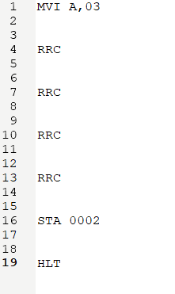

**OUTPUT:**



**RESULT:**

Thus the program was executed successfully  
using 8085 processor simulator.